Soya Paneer Making Machine

Automation Grade | Manual
Automatic Grade | Automatic, Semi-Automatic
Design Type | Standard, Customized
Condition | New
Application | Milk, Yogurt, Cheese, Milk Powder, Paneer
Product Details:
Capacity | 200/300/500 LPH
Material | SS 304
Voltage | 240 V
Certification | ISO Certified
Warranty | 1 Year
Machine Type | Automatic
Country of Origin | Made in India

A Paneer making machine, also known as a paneer press or paneer maker, is a piece of equipment used in the commercial production of paneer, a popular Indian cheese. Paneer making machines are designed to efficiently press and shape the paneer curds into blocks or desired shapes.
Here are some common features and functionalities of a paneer making machine:
- Pressing Mechanism: Paneer making machines typically have a pressing mechanism that exerts pressure on the paneer curds to expel excess whey and shape the cheese into blocks or moulds.
- Capacity: These machines come in various capacities, ranging from small-scale units suitable for home or small-scale production to large-scale industrial machines capable of processing large volumes of milk.
- Material: They are usually made of food-grade stainless steel, which ensures hygiene and durability.
- Automation: Some advanced models may feature automation for pressing, cutting, and shaping the paneer, reducing manual labour and increasing efficiency.
- Versatility: Depending on the model, paneer making machines may offer versatility in shaping paneer into different forms, such as blocks, cubes, or custom shapes.
- Ease of Cleaning: Good quality machines are designed for easy cleaning and maintenance, with removable parts and smooth surfaces.
- Safety Features: Industrial-grade machines may come with safety features such as emergency stop buttons and protective guards to ensure safe operation.
- Customization Options: Some manufacturers offer customization options based on specific production requirements, such as size, capacity, and additional features.

We Alfa Tech India, PUNE introduce ourselves as pioneers in the field of Manufacturing Soya Paneer Machine Fully Automatic Soya Paneer Making Machine Manufacturer In India The Leading Manufacturer And Suppliers Of Fully Automatic Soyabean Milk P
We Very Confidently Claim That Our Soya Milk Machine Quality Is Very Heavy Duty.
Get The Complete Knowledge Of How To Set The Soyabean Milk Plant Industry , We Have Heavy Duty Tofu Making Machine , Which Are Known For Its Quality In The Indian Market, .
According To Our Process Of Making Soya Paneer One Will Not Get Any Kind Of Beany Smell In Tofu
We Can Deliver Deliver The Soya Milk Machinery To Anywhere In India

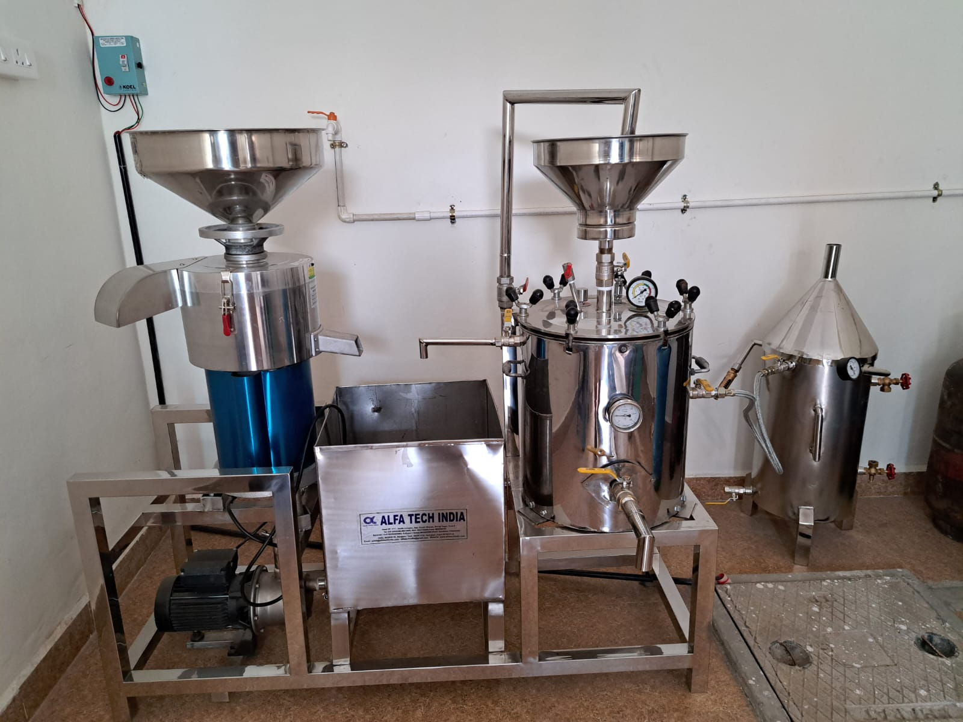

Soya Plant200/300/500LPH
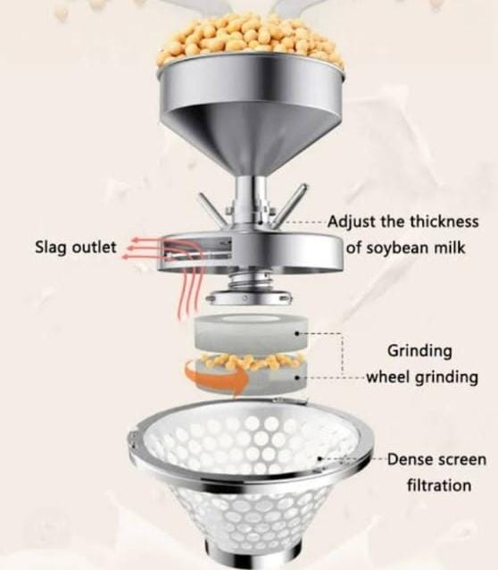

SOYA GRINDER
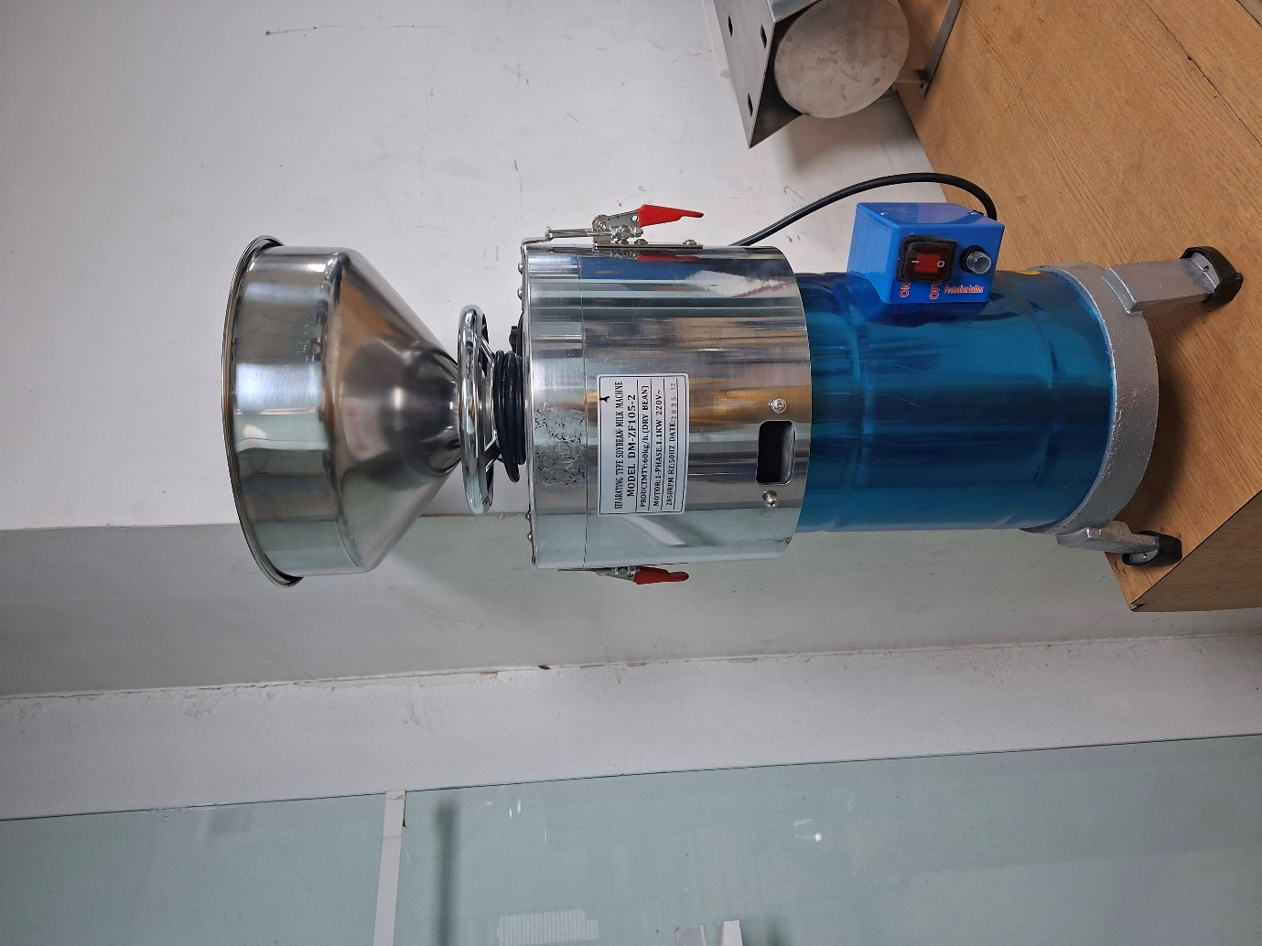

SOYA GRINDER
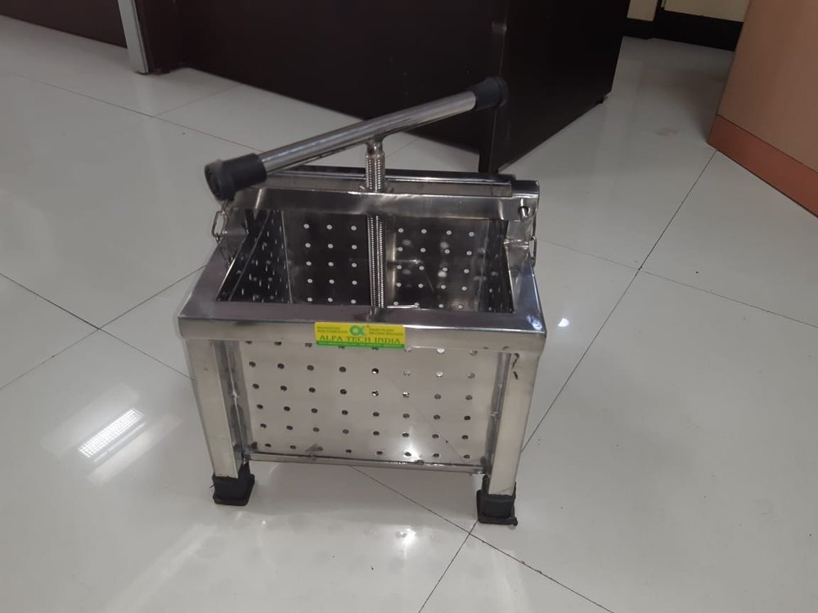
MECHANICAL PANEER PRESS

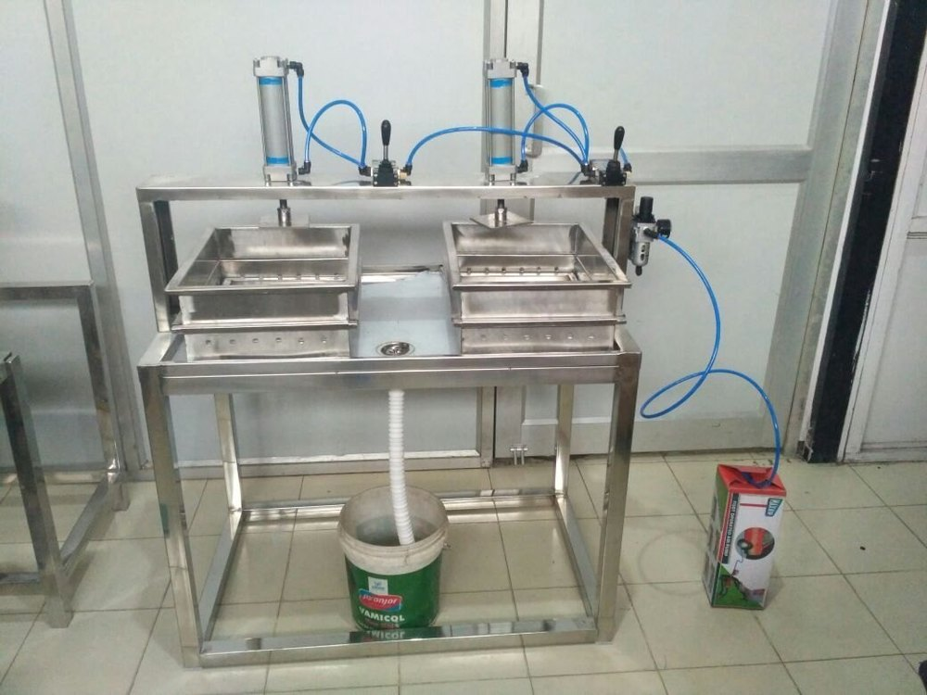

DOUBLE HEAD PNEUMATIC PANEER PRESS.

